***ICP2 REPORT***

### **1-1)-Counter. Count (Class Variable):**

This is a **class variable**, meaning it is shared across all instances of the Counter class.

**-self. Count (Instance Variable):**

This is an **instance variable**, meaning it is unique to each instance of the Counter class.

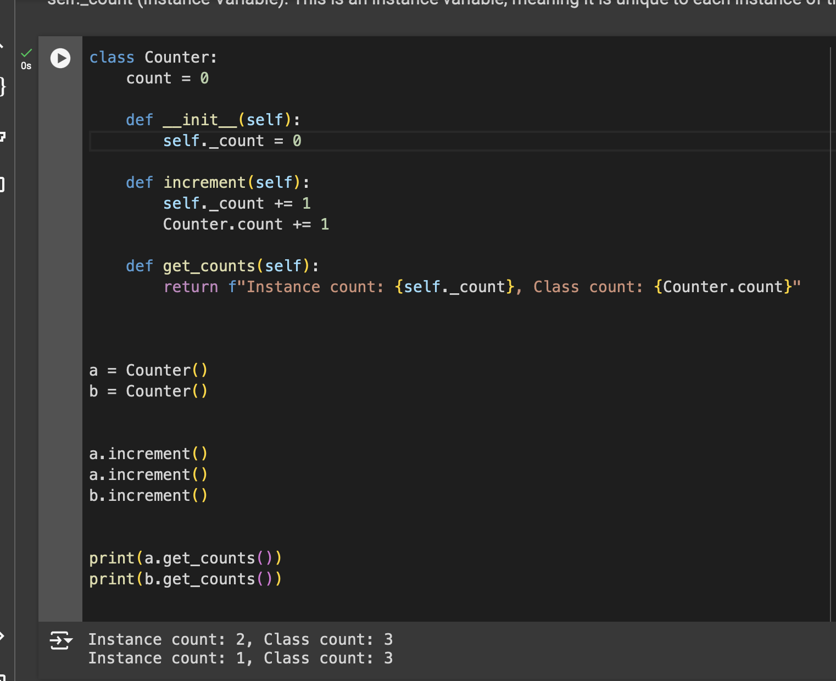

1-3) The increment method in the Counter class affects both the class variable Counter.count and the instance variable self. Count

* **a.increment()**:
  + Increases a._count from 0 to 1.
  + Increases Counter.count from 0 to 1.
* **a.increment()**:
  + Increases a._count from 1 to 2.
  + Increases Counter.count from 1 to 2.
* **b.increment()**:
  + Increases b._count from 0 to 1.
  + Increases Counter.count from 2 to 3.

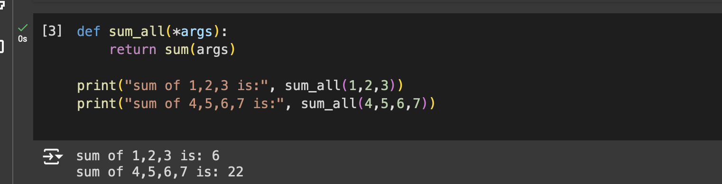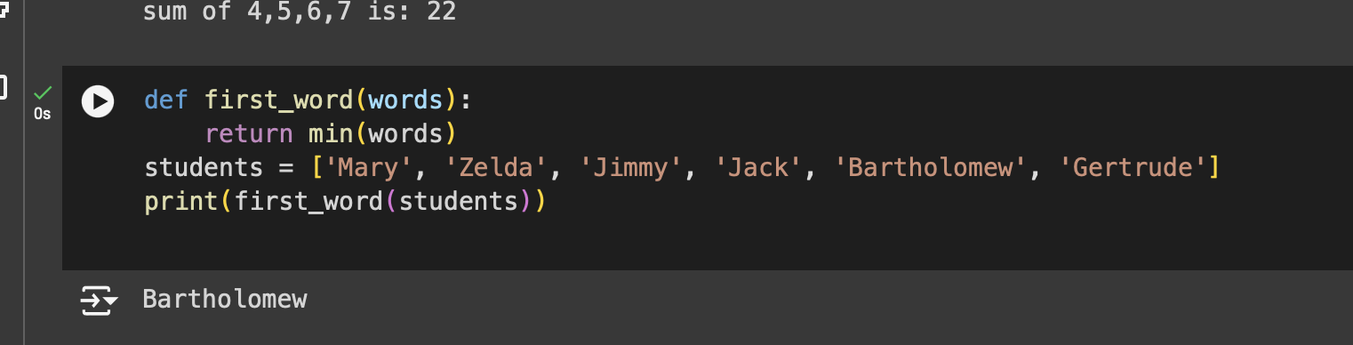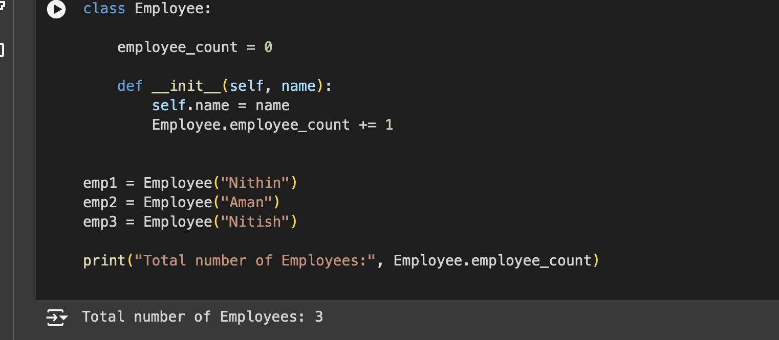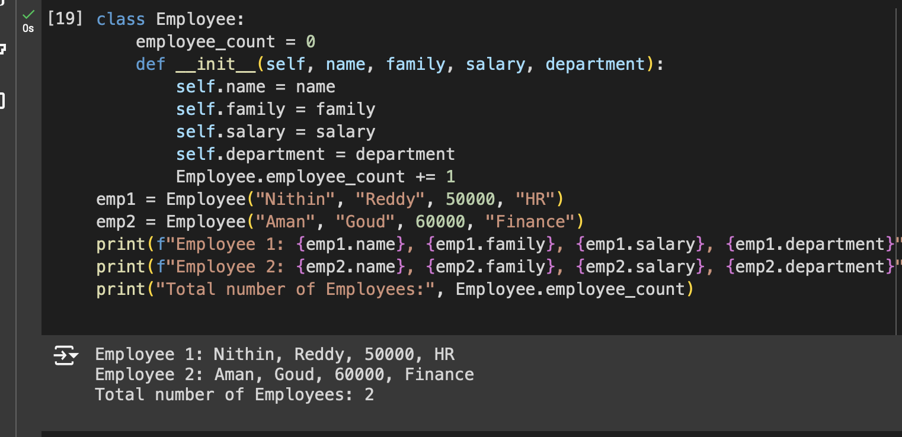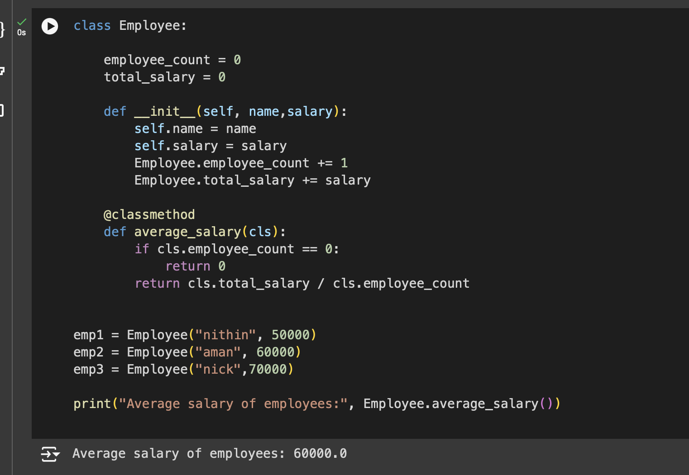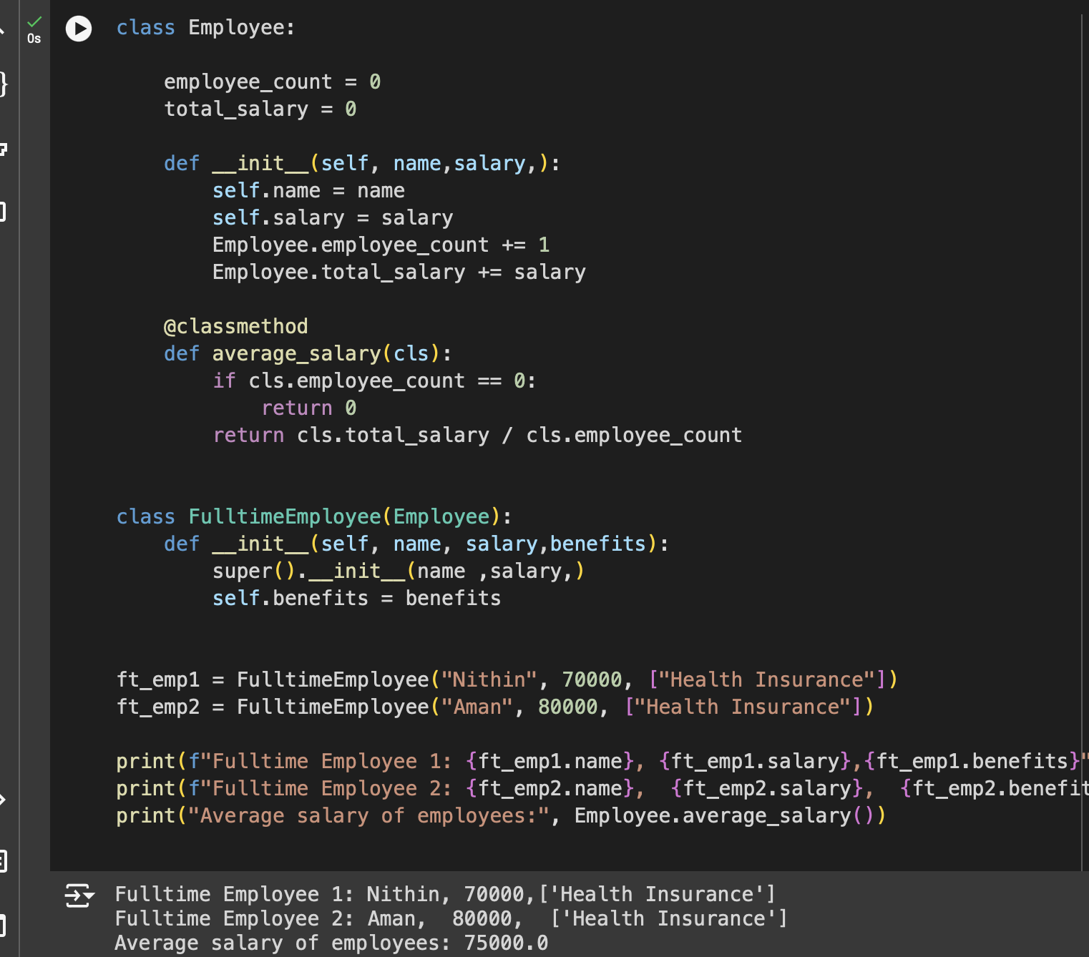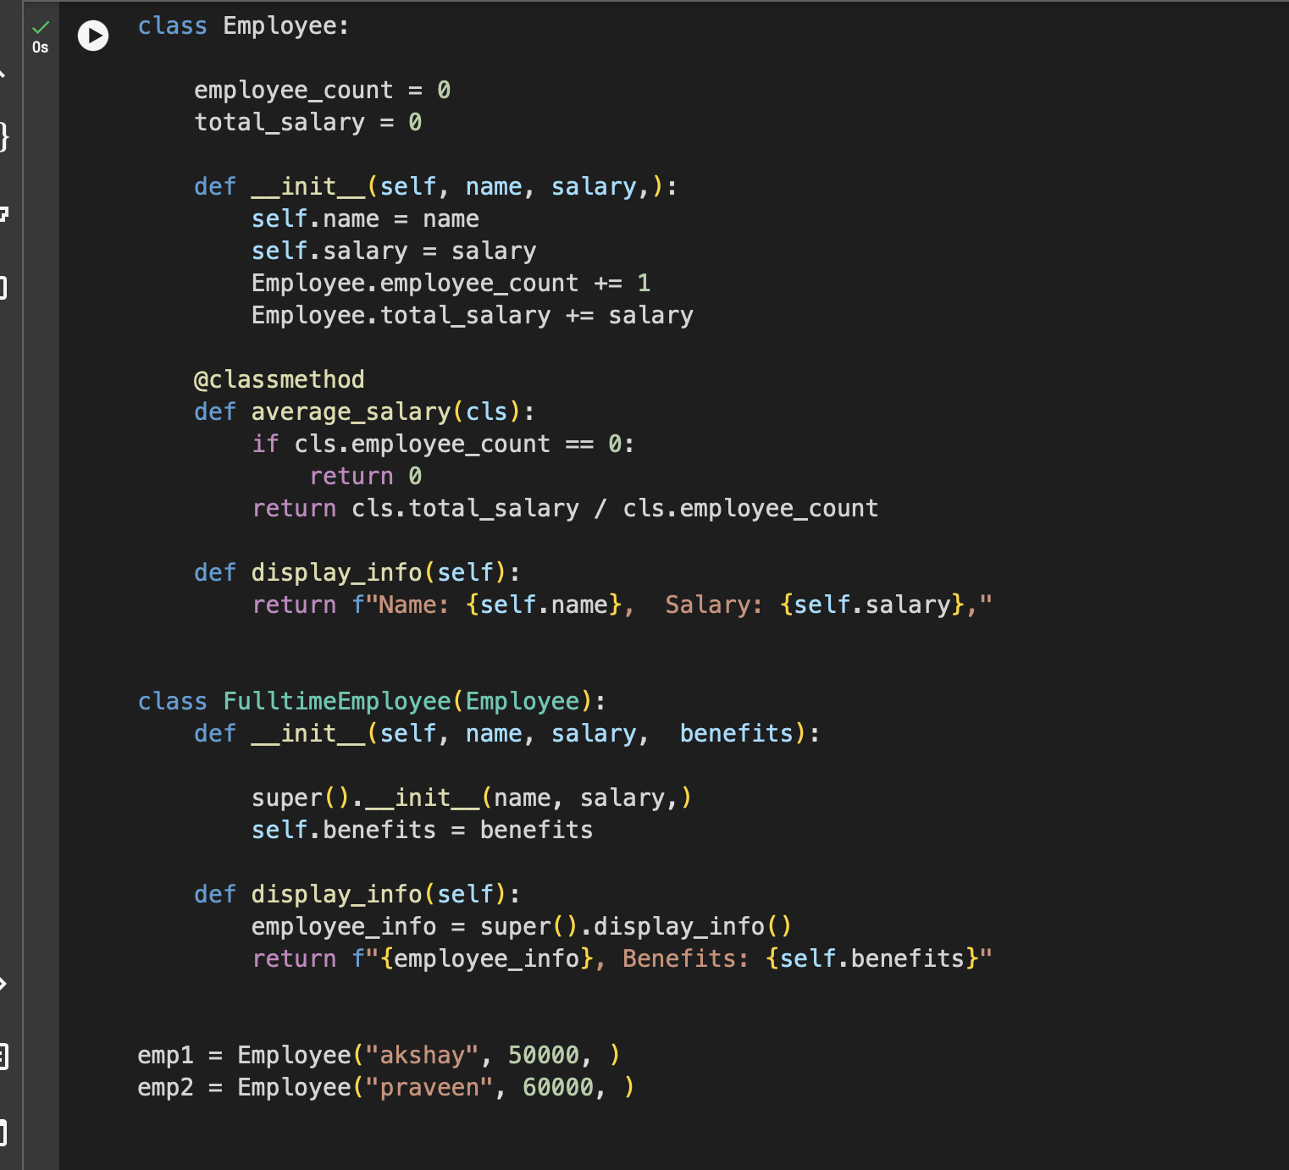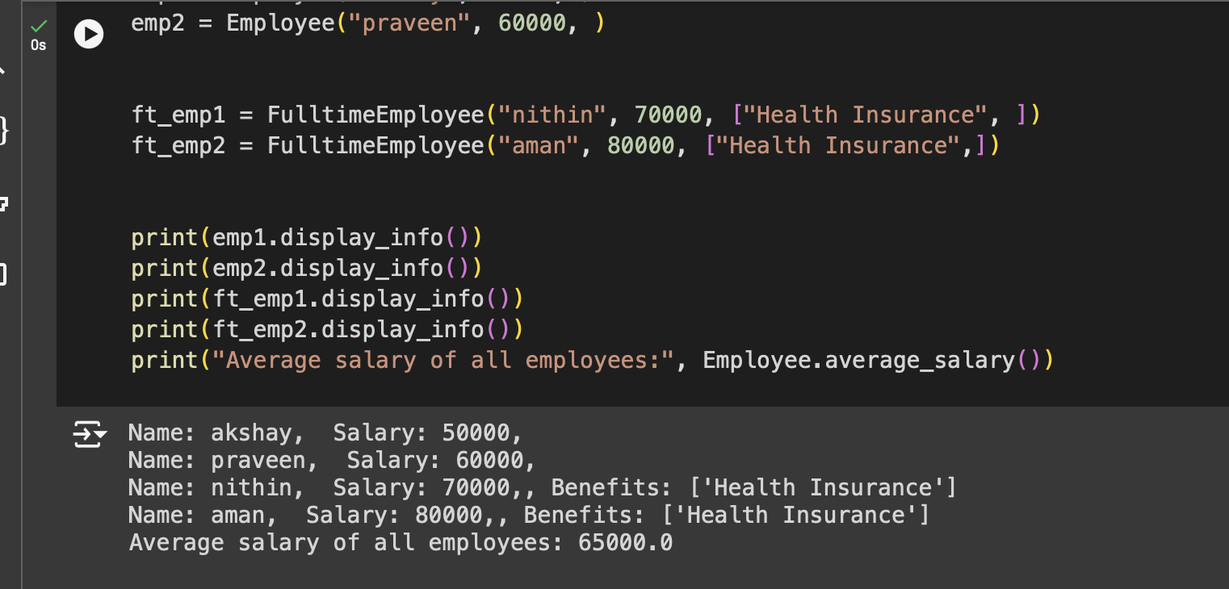

MY GITHUB LINK:<https://github.com/nithin1086/BDA.git>